Module–2(Manual Testing)

**1 What is Exploratory Testing?**

Exploratory testing is the practice of allowing tester to enter a product and find bugs and errors without the help of a script or test cases

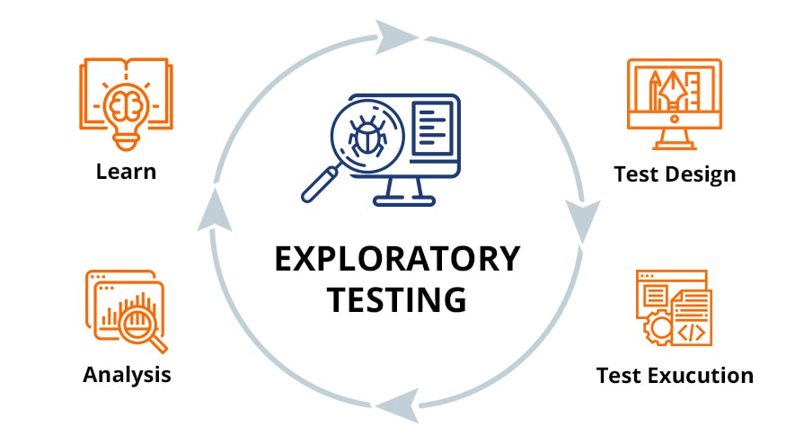

Exploratory testing is an approach to software testing that is concisely described as simultaneous learning, test design and test execution.

**2 What is traceability matrix?**

A traceability matrix is a document that details the technical requirements for a given test scenario and its current state. it helps the testing team understand the level of testing that is done for a given product.

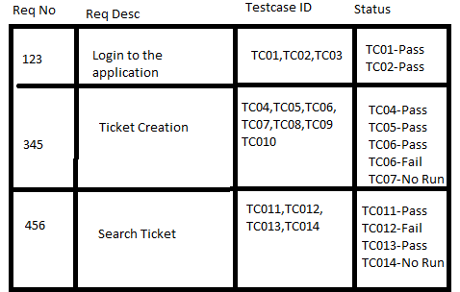

The traceability process itself is used to review the test cases that were defined for any requirement.

**3 What is Boundary value testing?**

Boundary-value analysis is a software testing technique in which tests are designed to include representatives of boundary values in a rang. The idea comes from the boundary. Given that we have a set of test vectors to test the system, a topology can be defined on that set.

Very clear guidelines on determining test cases without compromising on the effectiveness of testing.

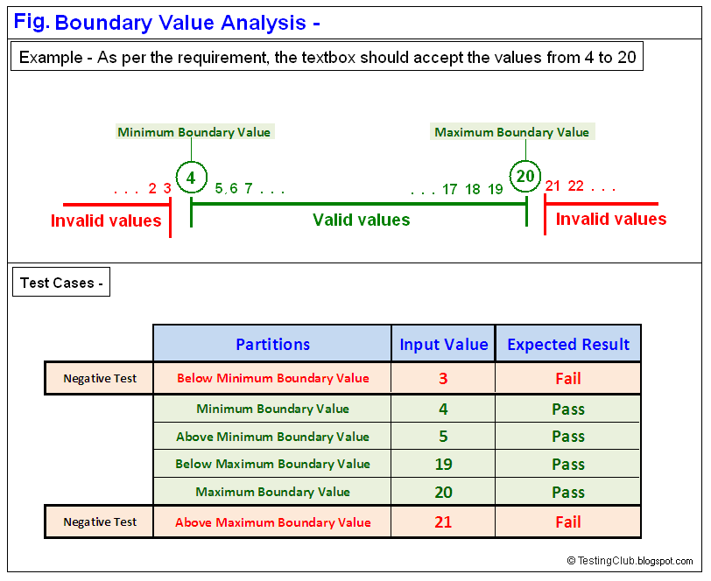

Appropriate for calculation-intensive applications with a large number of variables/inputs.

**4 What is Equivalence partitioning testing?**

Equivalence partition is a methodology to design the test case like to divide the rang in to equivalence partition and select. Representative input value to test each partition if.

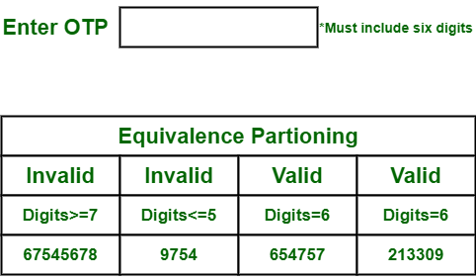

If the range condition is given as an input, then one valid and two invalid equivalence classes are defined.

If a specific value is given as input, then one valid and two invalid equivalence classes are defined.

**5 What is Integration testing?**

Integration testing is a level of the software testing process where individual units are combined and tested as a group.

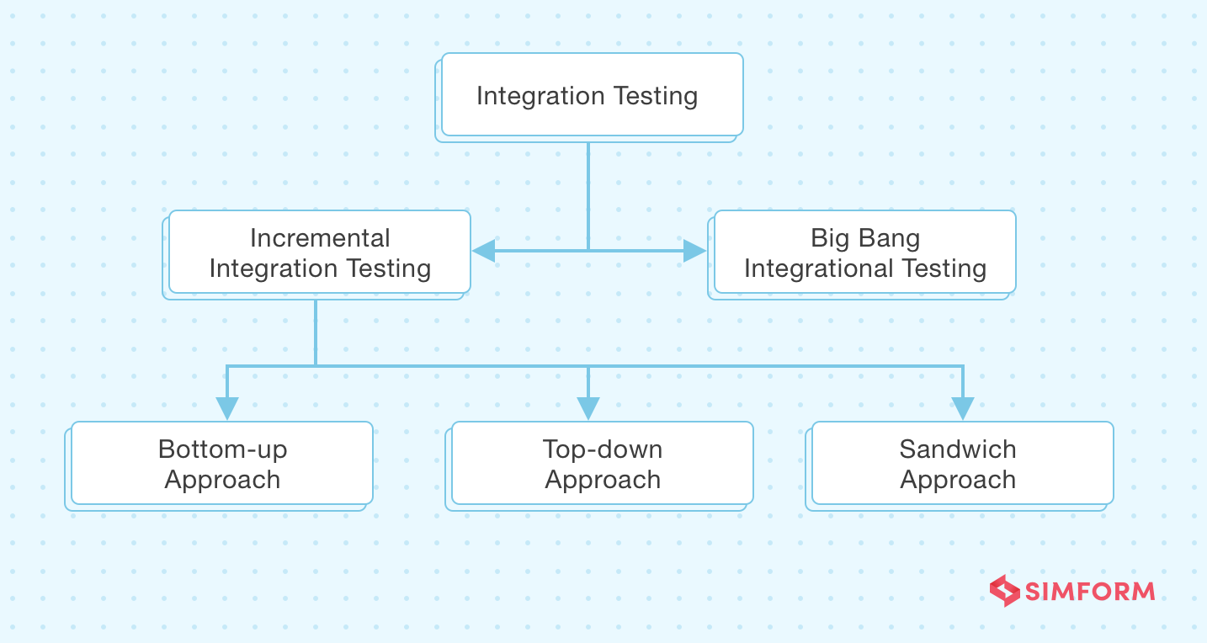

Example: Let us assume that we have a g-mail application where we perform the integration testing.

**6 What determines the level of risk?**

The level of risk is determining by various factors, including the nature of the activity or investment, market conditions, financial stability, and external influences. Assessing factors such as volatility, potential returns, and he probability of adverse events helps gauge and manage risk effectively.

**7 What is Alpha testing?**

Alpha testing is the first end-to-end testing of a product to ensure it meets the business requirements and functions correctly. It is typically performed by internal employees and conducted in a stage environment. An alpha test ensures the product really works and does everything it’s supposed to do.

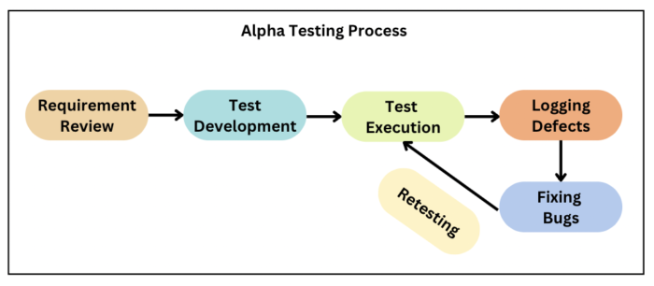

Review the design of the specification and functional requirement.

Test development is based on the outcome of the requirement review.

Execute the test plan and test cases.

**8 What is beta testing?**

Beta testing is an opportunity for real users to use a product in a production environment to uncover any bugs or issues before a general release. Beta testing is the final round of testing before releasing a product to a wide audience.

Beta testing used in a real environment at the user’s site. Beta testing helps in providing the actual position of the quality.

Testing performed by the client, stakeholder, and end-user.

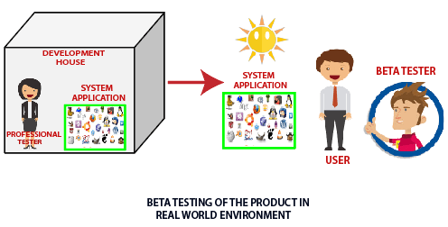

**9 What is component testing?**

Component (UNIT) testing is level of the software testing process where individual units/components of software/testing.

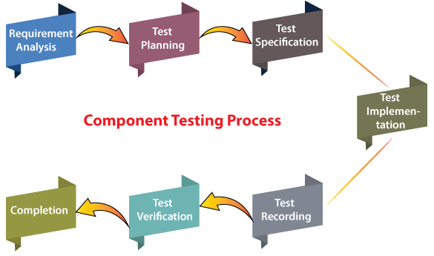

Suppose we have a web application containing three different modules as login, home page, and user.

The first module login is installed in the testing environment, but the other two modules, home and user, need to be called by the login modules that is yet to be finished.

**10 What is functional system testing?**

Testing the attribute(future) of the system. Directly too related to the functionality.

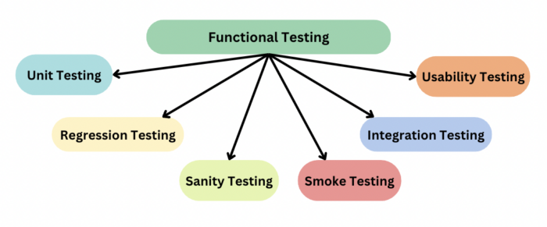

Functional testing is a type of testing that seeks to establish whether each application feature works as per the software requirements. Each function is compared to the corresponding requirement to ascertain whether its output is consistent with the end user’s expectations.

**11 What is Non-Functional Testing?**

Nonfunctional testing is a type of software testing that verifies nonfunctional aspects of the product, such as performance, stability, and usability. Whereas functional testing verifies whether or not the product does what it is supposed to, non-functional testing verifies how well the product performs.

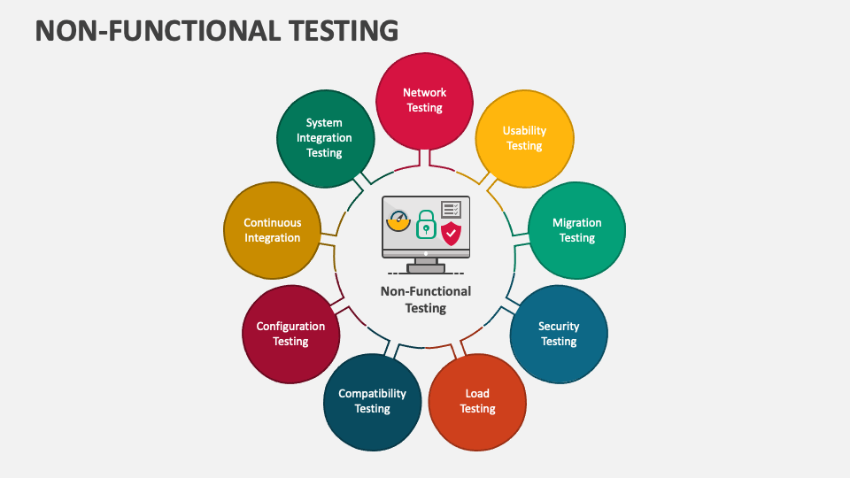

Non-functional testing should increase usability, efficiency, maintainability, and portability of the product.

Helps to reduce production risk and cost associated with non-functional aspects of the product.

**12 What is GUI Testing?**

GUI testing involves checking the screens with the controls like menus, button, icon, and all types of bar-tool-bar, menu bar, dialog box and windows etc.

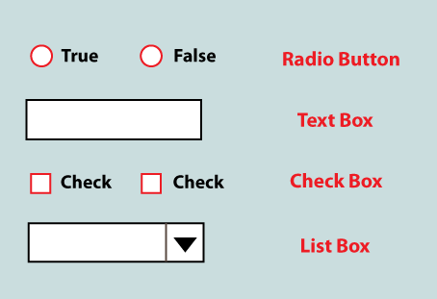

Examples:

1 Testing the size, position, width, height of the elements.

2 Testing of the error messages that are getting displayed.

3 Testing the different sections of the screen.

4 Testing of the font whether it is readable or not.

5 Testing the alignment of the texts and other elements like icon, buttons, etc.

**13 What is Adhoc testing?**

Adhoc testing is a type of software testing that is performed without a predetermined test plan or script. This method involves exploring or testing features spontaneously as the tester perceives potential issues or areas that require further testing.

It is an informal testing with an aim to break the system.

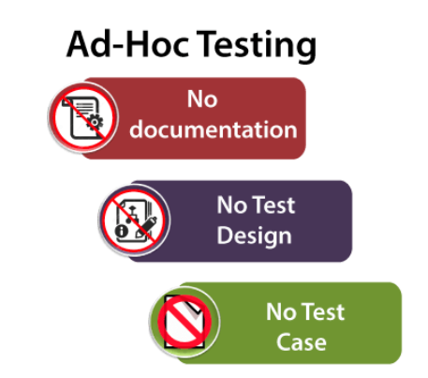

Testing an application’s functionality when the browser settings are altered. Identifying faults that occur when the JavaScript option is deactivated in various browsers.

**14 What is load testing?**

Load testing determines the behavior of the application when multiple users use it at the same time. It is the response of the system measured under varying load conditions.

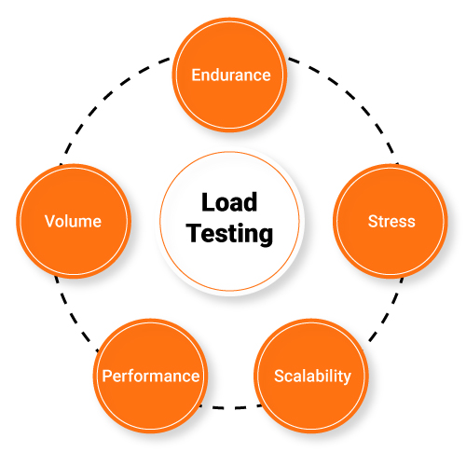

Examples:

1 Downloading a series of large files from the internet

2 Running multiple applications on a computer or server simultaneously.

3 Assigning many jobs to a printer in a queue.

**15 What is stress Testing?**

Stress testing is software testing used to determine how an application or system behaves when under extreme levels of stress. This testing puts the system or application through scenarios designed to push it beyond its normal limits.

The primary purpose of executing the stress testing is to confirm that the software does not crash in lacking computational resources like disk apace, memory, and network request.

**16 What is white box testing and list the types of white box testing?**

White box testing is a form of application testing that provides the tester with complete knowledge of the application being tested, including access to source code and design documents.

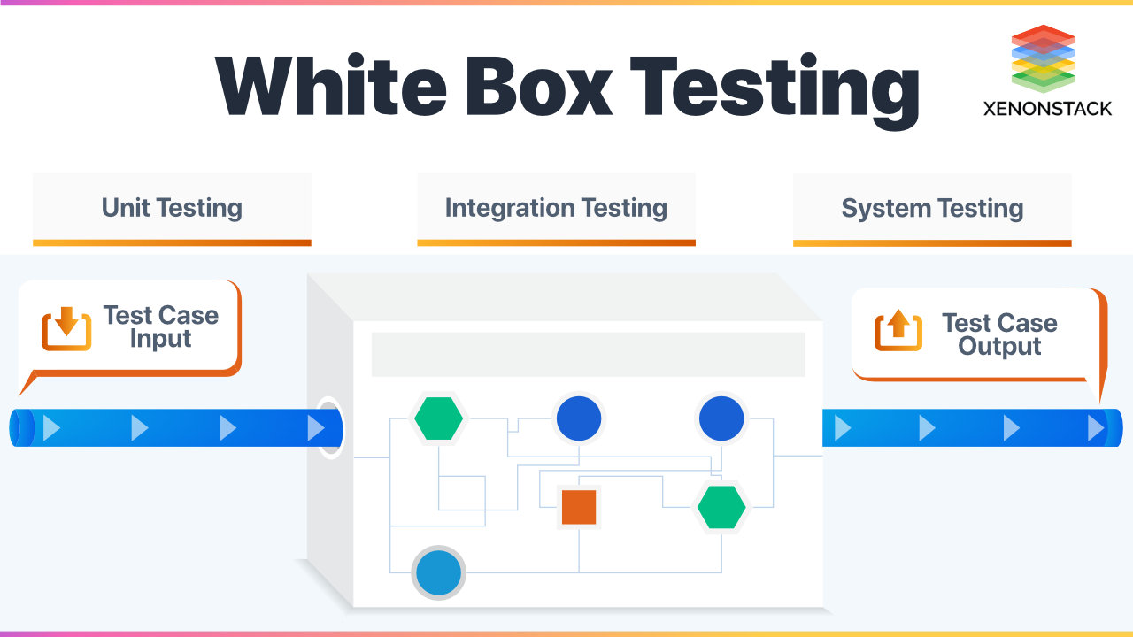

White box testing types include unit testing, static and dynamic analysis, statement, branch, path coverage, security testing, loop and conditional testing, mutation and integration testing, penetration testing, and memory perspective testing.

**17 What is black box testing? What are the different black box testing techniques?**

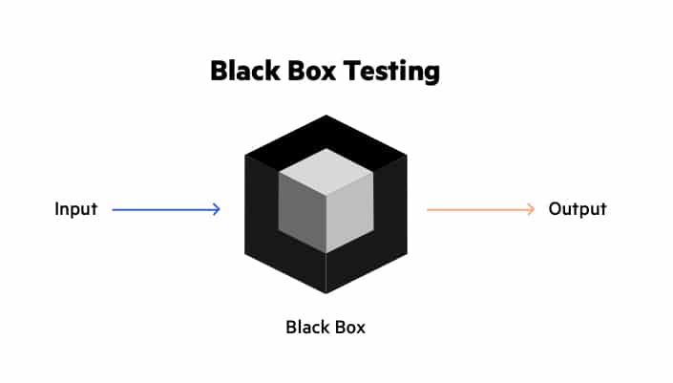

Black box testing is a type of software testing in which the tester is not concerned with the internal knowledge or implementation details of the software but rather focuses on validating the functionality based on the provided specifications or requirements.

Black box testing techniques …

**Equivalence partition:**

Equivalence partitions a methodology to design the test case like to divide the rang in to equivalence partition and select reprangentative input value to test each partition if.

If repregantitave value will be passed the whole will be passed if the repregantitave will be failed, the whole will be failed.

Example: If value is between 1 and 100 than value > = 1 and value < = 100

**Boundary value analysis:**

It is batter version of equivalence partitions value the boundary like upon and lower

**Decision table: (Boolean)**

A decision table is a good way to deal with combination of things

Example: input

**State transaction:**

State transaction is used when the system can be describing set of input stored in state machine.

Different output for the same input depend has happened before is a finite system.

**18 Mention what are the categories of defects?**

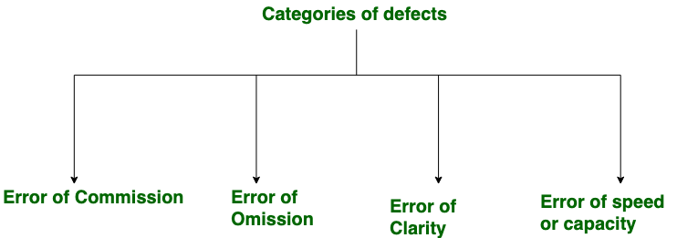

Categories of defects are errors of commissions, errors of omissions, errors of clarity, and error of speed and capacity.

Software defect is some kind of error, flaw or some kind of mistake from the development team which prevent the software from the smooth working. It directly affects software quality, software quality is something how smooth and reliable your software is smoothness and reliability is how less defects your software.

**19 Mention what big bang testing is?**

Big bang integration testing is an integration testing strategy wherein all units are linked at once, resulting in a complete system. When this type of testing strategy is adopted, it is difficult to isolate any errors found, because attention is not paid to verifying the interfaces across individual units.

1 The whole system is tested

2 Requires minor planning

3 Consists of completed and checked modules.

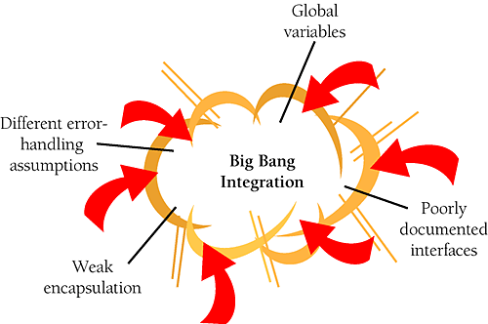

4 There is no demand for urgent build fixings.

5 Suitable for small systems.

**20 What is the purpose of exit criteria?**

Exit criteria serve as predefined condition or benchmarks that must be met before a project, phase, or task is considered complete. They help ensure that the objectives have been achieved, quality standards are met, and stakeholder’s expectations are fulfilled before moving on to the next stage or closing the project.

Creating exit criteria helps:

1 Align your teams on a common definition of test completion

2 Ensure your product meets completion standards before entering the next stage, which avoids costly project delays

3 Create clear parameters for test engineers to evaluate software.

**21 When should "Regression Testing" be performed?**

Regression testing should be performed whenever there are changes or updates to the software, such as new features, bug fixes, or code modifications, to ensure that existing functionalities remain unaffected. It helps identify and fix any unintended side effects that might occur due to the changes made in the codebase

**22 Difference between QA v/s QC v/s Tester**

|  |  |  |
| --- | --- | --- |
| **QA** | **QC** | |
| 1 Focuses on process rather than conducting actual testing on the system. | 1 Focuses on actual testing by executing software. | |
| 2 Process oriented activities. | 2 Product oriented activities. | |
| 3 Preventive activities | 3 It is a corrective process. | |
| 4 It is a subset of (STLC) | | 4 QC is a subset of a QA |

**23 Difference between Smoke and Sanity?**

|  |  |
| --- | --- |
| Smoke | Sanity |
| Smoke testing is done to assure that the acute functionalities of program is working fine. | Sanity testing is done to check the bugs have been fixed after the build. |
| Smoke testing is also called subset of acceptance testing. | Sanity testing is also called subset of regression testing. |
| Smoke testing is documented. | Sanity testing is not documented. |
| Smoke testing may be stable or unstable. | Sanity testing is stable. |
| Smoke testing is scripted. | Sanity testing is usually not scripted. |

**24 Explain types of Performance testing.**

It is the most important part of non-functional testing.

Checking the behavior of an application by applying some load is known as performance testing.

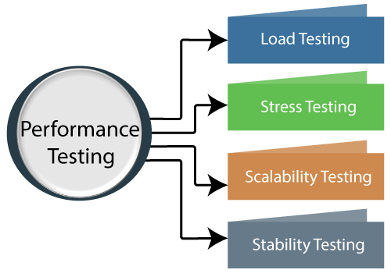

Let us take one examples where we will test the behavior of an application where the desired load is either less than 1000 or equal to 1000 users.

In the below image. We can see that 100 up users are increased continuously to check the maximum load which is also called upward scalability testing.

**Load Testing**: Load testing determines the behavior of the application when multiple users use it at the same time. It is the response of the system measured under varying load conditions.

Stress Testing: **Stress Testing** is a form of deliberately intense or thorough testing, used to determine the stability of a given system, critical infrastructure or entity. It involves testing beyond normal operational capacity, often to a breaking point, in order to observe the results.

**25 What is Error, Defect, Bug and failure?**

Error: Mistake in coding is called.

Defect: Error found tester is called defect

Bug: Defect accept by development team is called bug

Failure: Build does not meet requirements.

**26 Explain the difference between Functional testing and Nonfunctional testing**

|  |  |
| --- | --- |
| **Functional Testing** | **non-functional Testing** |
| 1 It focuses on testing the functionality of the software testing. | 1 It focuses on testing the non-functional aspects of the software or system. |
| 2 It verifies the operations and actions of application. | 2 It verifies the behavior of an application. |
| 3 It is based on requirements of customer. | 3 It is based on expectation of customer. |
| 4 It helps to enhance the behavior of the application. | 4 It helps to improve the performance of the application. |
| 5 Functional testing is easy to execute manually. | 5 It is hard to execute non-functional testing manually. |

**27 To create HLR & Test Case of**

1. (Instagram, Facebook) only first page
2. Facebook Login Page: https://www.facebook.com

|  |  |
| --- | --- |
| Instagram HLR, Test Case | Click here |
| Facebook HLR, Test Case | Click here |
| Facebook Login page HLR, Test Case | Click here |

**28 What is the difference between the STLC (Software Testing Life Cycle) and SDLC (Software Development Life Cycle)?**

|  |  |
| --- | --- |
| **SDLC** | **STLC** |
| SDLC is mainly related to software development. | STLC is mainly related to software testing. |
| Goal of SDLC successful development of software. | Goal of STLC is to complete successful testing of software. |
| It helps in developing good quality software. | It helps in making the software defects free. |
| SDLC phases are completed before the STLC phases. | STLC phases are performed after SDLC phases. |
| Creation of reusable software systems is the end result of SDLC | A tested software system is the end result of STLC |

**29 What is the difference between test scenarios, test cases, and test script?**

|  |  |  |
| --- | --- | --- |
| **Test scenario** | **Test case** | **Test script** |
|  |  |  |
| A test scenario contains high-level documentation which describes an end to end functionality to be tested. | Test cases contain definite test steps, data, expected results for testing all the features of an application. | Test script is set of instructions or a short program to test any functionality of software product. |
| It focuses on more what to test than how to test. | A complete emphasis on what to test and how to test. | Test script is an automatic approach of software testing. |
| Test scenarios are derived from test artifacts like BRS, SRS, etc…. | Test case is mostly derived from test scenarios; multiple test case can be derived from a single test scenario. | Test script is used in automatic testing environment. |
| Test scenario are high-level actions. | Test cases are low-level actions. | Test scripting is done by scripting format. |

**30 Explain what Test Plan is? What is the information that should be covered?**

A test plan is detailed document that describes the test strategy, objectives, schedule, estimation, deliverables, and resources required to perform testing for a software product. Test plan helps us determine the effort needed to validate the quality of the application under test. The test plan serves as a blueprint to conduct software testing activities as a defined process, which is minutely monitored and controlled by the test manager.

“Test plan is a document describing the scope, approach, resources, and schedule of intended test activities.”

Making test plan document has multiple benefits

Helps people outside the test team such as developers, business managers, customers understand the details of testing.

Test plan guides our thinking. It is like a rule book, which needs to be followed.

Important aspects like test estimation, test scope, test strategy are documented in test plan, so it can be reviewed by management team and re-used for other projects.

**31 What are the different Methodologies in Agile Development Model?**

Agile development encompasses several methodologies, each with its own approach to managing the software development process. Some popular agile methodologies include

1 Scrum: A framework that emphasizes iterative development in fixed-length time intervals called sprints. It includes defined roles, ceremonies, and artifacts to structure the development process.

2 Kanban: Focuses on visualizing the workflow and continuously improving the process. It allows for a more flexible approach to development with a focus on minimizing work in progress.

3 Extreme programming: Emphasizes practices such as pair programming, continuous integration, and frequent releases to ensure high-quality software development.

**32 Explain the difference between Authorization and Authentication in Web testing. What are the common problems faced in Web testing?**

|  |  |
| --- | --- |
| **Authentication** | **Authorization** |
| In the authentication process, users or persons are verified. | While in this process, users or person are validated. |
| The user authentication is visible at user end. | The user Authorization is not visible at the user end. |
| It is done before the Authorization process. | While this process is done after the authentication process. |
| It needs usually the user’s login details. | While it needs the user’s privilege or security levels. |

**33 To create HLR & Test Case of Web Based (WhatsApp web, Instagram) 1. WhatsApp Web:** <https://web.whatsapp.com>

1 WhatsApp Web: <https://web.whatsapp.com>

|  |  |
| --- | --- |
| WhatsApp Web HLR, Test Case | Click here |

2 Instagram

|  |  |
| --- | --- |
| Instagram HLR, Test Case | Click here |

**34 Write for scenario pen, door, ATM, microwave Owen, coffee vending machine, chair, flip kart, WhatsApp group, lift, Gmail, create scenario positive and negative.**

|  |  |
| --- | --- |
| Write for scenario | Click here |

**35 When to used Usability Testing?**

Usability testing is used when you want to assess how user-friendly a product or system is by observing real users interacting with it. It is typically conducted during the design and development phase to identify and address usability issues, ensuring a more positive user experience.

**36 What is the procedure for GUI Testing?**

For GUI testing, the product being tested is typically a software application for system with a user interface. This could include websites, desktop applications, mobile apps, or any software that involves user interaction through graphical elements such as buttons, menus, and forms. The goal of GUI testing is to ensure that the interface functions correctly, is visually appealing, and provides a smooth user experience.